

CONFIDENTIAL
Security Camera System Quotation
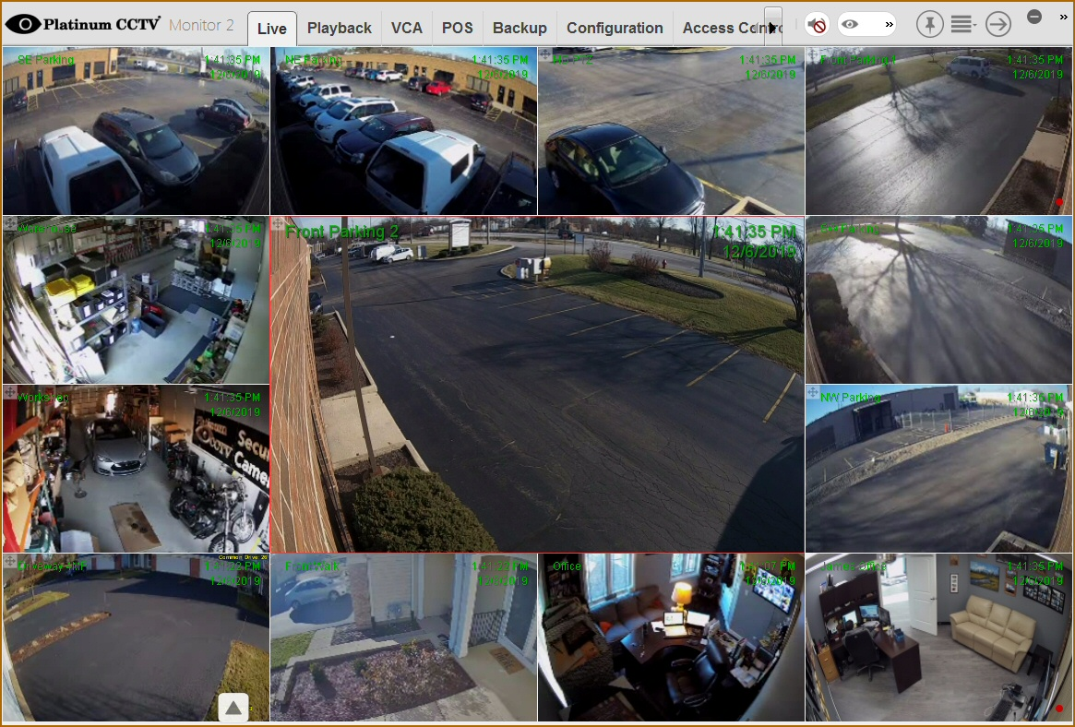
Don’t Ever Purchase a Camera System
if they don’t show you remote access & playback IN ADVANCE!
We love to show it off, because no one can touch our AVM System
Camera System Quote
,
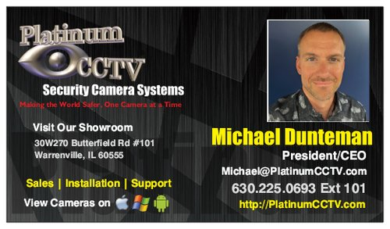
Provided by
Michael Dunteman
Platinum CCTV Surveillance Solutions
30W270 Butterfield Rd #101
Warrenville, IL 60555
630.225.0693 Ext #111
Table of Contents:
- System Description and Features

  - Enhanced Features – AVM System 3

  - MUST SEE VIDEOS about our AVM System 4

  - Unrivaled Motion Detection 5

  - Enterprise-Grade Remote Access 5

  - System Security 6

- About the Quotations
  - NVR Recorder 8
  - Cameras 14
- System Quotations
  - Main system Layout 15
  - System Quotes 16
  - Warranty
  - Quotation Acceptance Sign Sheet
  - Certificate of Insurance and W9
  - Key Security Camera Coverage Notes
- Supporting Documentation
  - HD Camera Comparison
  - References
  - AVM System Brochure

